asciitube: Now Playing
Category: Web | Difficulty: Easy

Description
RowdyCon Systems just racked their coolest toy yet: asciitube, a Model AT-1987 "video cassette terminal" that takes any video link, fetches it, and beams it back to your browser as glorious phosphor-green ASCII.
The intern wired it up over the weekend and shipped it straight to production. "It just grabs whatever URL you paste and plays it — simple!" There's a little maintenance service humming away on the same box that was never meant to face the outside world, but hey, it's only listening on localhost. What could possibly go wrong?
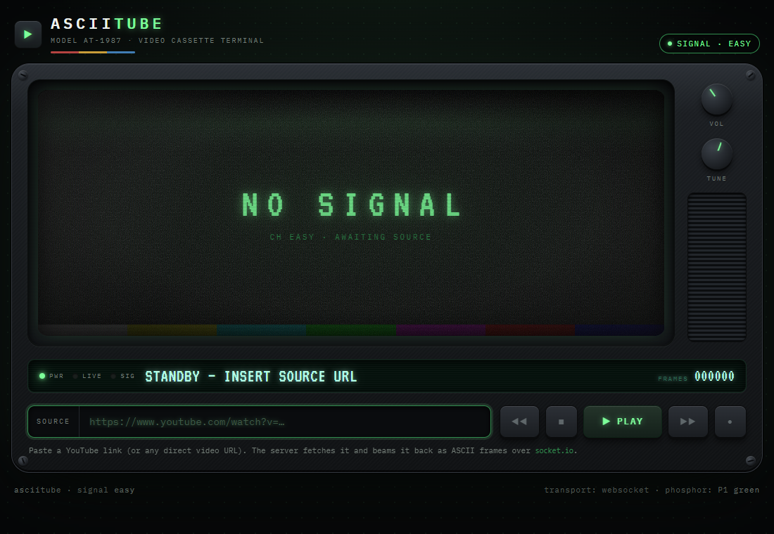
The asciitube AT-1987 terminal, awaiting a source URL

Files
One hosted Docker container, built from challenge/. From that folder:
cd challenge
docker compose up --build -d # serves http://localhost:5001
The player is published on 5001; the internal flag service (0.0.0.0:9000 inside the container) is never published — it's reachable only through the player's server-side fetch. The flag is set via FLAG in challenge/docker-compose.yml. Flask + Socket.IO app in challenge/app.py. Reference solvers and writeups are in organizer/: solve/solve_easy.py, README.md, solution.md.
Note: the build fetches a short YouTube clip for a gag ("caught" video). It's non-fatal if the build host has no network — the app fetches it once at runtime instead — and it has no bearing on the solve.

Hint(s)
- It's the *server* that fetches your link, not your browser — so it can reach things you can't, like a service listening on its own loopback interface.
- Something is answering on a high port inside the box. Ask the terminal to "play" it, and watch what it shows you when the bytes it got back aren't actually a video.

Walkthrough
A reflected Server-Side Request Forgery (SSRF). asciitube fetches the "video" URL you submit *server-side*; if the bytes don't decode as a video, it reflects the raw response body back into the page. On easy there is no host filtering — the only check is a global anti-abuse gate requiring the URL string to contain the substring youtube.
- Spot the SSRF sink. The terminal fetches whatever URL you paste, from its own network position. That reaches services bound to localhost inside the container that you can't hit directly. An internal metadata/flag service listens on 127.0.0.1:9000 and serves the flag at /flag.
- Satisfy the gate, aim at the internal service. Point the player straight at the internal service and append a #youtube fragment:
```
http://127.0.0.1:9000/flag#youtube
```
- #youtube makes the string contain youtube, so the gate passes.
- Fragments are never sent to the server, so the real request is GET /flag.
- /flag returns text/plain, which doesn't decode as video — so the player reflects the body.
- Read the flag. Paste the URL into SOURCE, press PLAY, and the amber "intercepted signal" panel shows the fetched response — the flag:
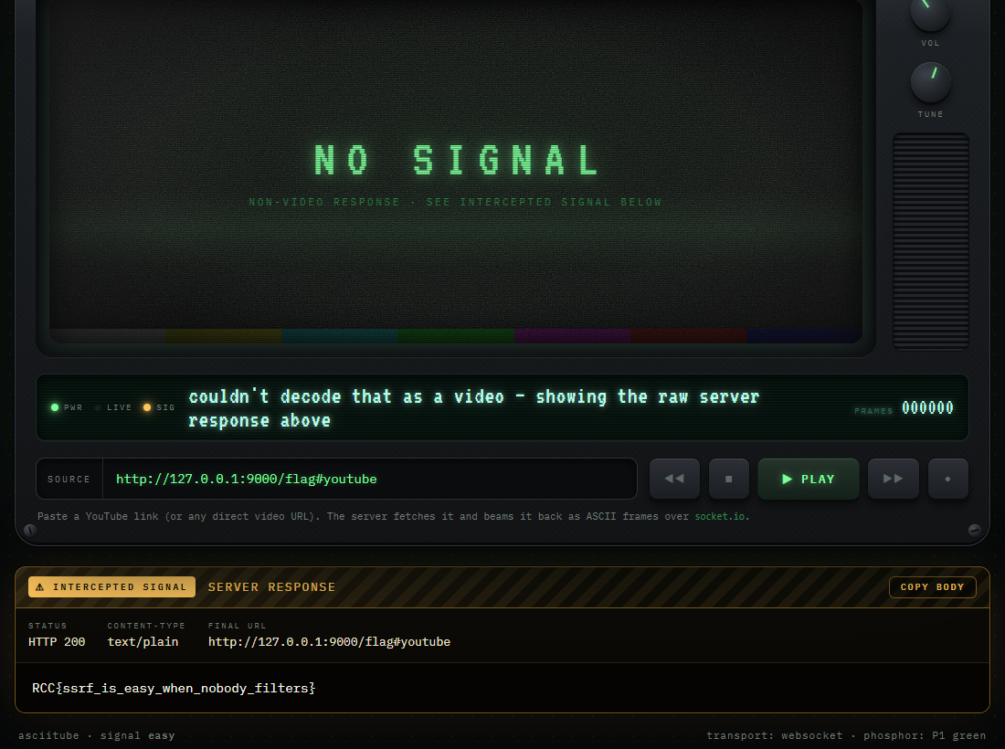
SSRF to the internal :9000/flag, reflected in the terminal
(The reference solve/solve_easy.py does the same over Socket.IO.)

Flag
RCC{ssrf_is_easy_when_nobody_filters}

